ARREST & EXECUTION LIST UPDATED 6-28-20
I thought Bill & Melinda Gates would have been executed by now, but I had no intel of that. Well there is a reason for that. They were already dead and they were dealing with doubles. I received intel that they were in India in 2013 giving children vaccinations and many died, or were left paralyzed because of the vaccine. The people who had their children vaccinated and had died or paralyzed seized the two and hanged them both at the same time in July of 2013. They both died in July of 2013.
The persons they have on house arrest are not them. They are doubles
TAKE NOTE. SOME OF THE PERSONS ARRESTED HAS RESULTS CHANGED FROM WAITING FOR TRIBUNAL TO EXECUTION OR LIFE
PEOPLE WHO ARE SERVING LIFE HAVE RECEIVED A PLEA DEAL. IF THEY VIOLATE THE TERMS OF THE DEAL THE DEATH SENTENCE WILL BE SERVED
ANYONE WHO IS NOT IN THE LIST IS BECAUSE I DON’T HAVE INTEL ON THAT PERSON
LIST OF ARRESTED & EXECUTED
Before you scroll down to see the list, Read this explanation. The tribunals are arresting these people in plain clothes. We saw the arrest of Obama’s. The arrest was done nonchalantly so as to not get noticed by the public. Just in case you missed it.
All arrests of these people were done that way. If the person is convicted of child sex trafficking, or crimes against humanity, they will be executed. It they are convicted of treason they will be executed. Before the trial, if the person has evidence on someone else to help the prosecution or is willing to help Trump. and they want to cooperate and do things for trump to drop a possible sentence of execution down to life in prison then they are allowed to do that if the evidence is worth anything. When a plea deal is done the defendant has to present anything they have to make the possible sentence lighter. That information is given to the prosecution, defense, and to the judge. If it is accepted they are presented the plea deal, and then they have to make a written statement and plead guilty to the crime with a video confession and the written statement. That is how all plea deals work.
All of the people arrested were either treasonous or involved in Satanic worship rituals involving torchuring children then murdering them as a sacrifice. Then drinking their blood that contains adrenochrome. This is called crimes against humanity and calls for death. Trump signed an Executive Order calling for the death penalty for anyone involved in crimes of humanity or treason to be given a tribunal and sentenced to execution
If the arrested were taking orders from the cabal & carrying out those orders. That is called Treason
Obama said “I was only following orders” . Yeah orders that made him commit treason. He made a pea deal and was let out for a time to help Trump, but somewhere along the line he violated the plea deal and was rearrested and was put before a firing squad and shot in the back of the head. Lying Big Mike was executed shortly after. We will find out next year when all this is released. Obama turned over on Big Mike to get a plea deal.
Everyone who was arrested made a video confession, to get a plea deal, even if it was just death by lethal injection instead of firing squad or hanging. Lethal injection is a preferred way to die. You simply fall asleep and don’t wake up. It is painless and peaceful. Big Mike got the lethal injection, I have to think he made a video confession.
Everyone who has been executed has a double or clone. These are put in place by the white hats to make people think they are still around. That is so the people who are are not awake will not get angry or upset enough to start riots against the government for executing someone they loved. Like Madonna, or other celebrity. Or get so upset they have to go to the hospital. I know some people who would have to be put in the psych ward. They will be unable to accept that they have been lied to all their life. Believe it or not there are many democrats out there who still love obama & Michelle. Michelle has recently been on PBS reading books to children, Obama appeared with her in one session. These are videos that are done with CGI. They are fake. They both are dead.
If you see a video of the person arrested and executed, it is done by CGI. If the person is making a personal appearance, it will be a double or a clone. The Pence that you have seen on tv with Trump is a clone. He was arrested long ago after the coup he was involved in with Paul Ryan
If a person has died of corona virus, they will not get a double, because people know he died.
Harvey Weinstein turned over on everyone in Hollywood. It is has been destroyed
John McCain was executed and his daughter admitted it on the view. If you haven’t seen it here is is.
HRC died the day she spoke at the 9/11 event and collapsed at the SUV when she was told she was under arrest. They rushed her to her daughter house because it is a medical facility for her. A double came out and said she was ok. At this medical facility at Chelsea’s place she was revived by very interesting technology using adrenochrome and babies blood. She was given a tribunal and she was executed. All video confessions was done in analog video.
By the way GITMO is full. Some of the people who were arrested and on house arrest or at GITMO, are still in the tribunal negotiating a deal. Gates for instance will not be able to negotiate a deal because we already have the same evidence that he is using to get a deal. It won’t work. He will be executed.
There are many many who have been arrested who did not make this list because they just weren’t famous enough. There have been thousands of arrests
I have not provided dates of arrests or executions because I don’t have that info. Most of these people were charged with crimes against humanity. Some were charged with treason. Some were charged with both
I may have missed someone famous on the list because I had not been able to confirm it at the time the list was made. The list was made yesterday. I apologize for the messed up format. Patreon just does’t want to cooperate with me on that.
NOTE: THERE HAVE BEEN THOUSANDS OF ARRESTS AROUND THE WORLD. IT IS NOT POSSIBLE TO LIST THEM ALL. HERE IS JUST A FEW. DON’T ASK ME ABOUT THIS PERSON OR THAT PERSON. I WILL UPDATE THE LIST WHEN I GET THE INTEL.
Here is the arrested and/or executed list:
ANDREW McCABE ARRESTED & SERVING LIFE
BARACK OBAMA ARRESTED & EXECUTED
MICHELLE OBAMA (BIG MIKE) ARRESTED & EXECUTED
BILL GATES DECEASED
MELINDA GATE DECEASED
MIKE PENCE ARRESTED & EXECUTED
ANTHONY FAUCI ARRESTED & RELEASED FOR A TIME TO HELP TRUMP
HUMA ABEDINE ARRESTED & EXECUTED
JOHN BRENNAN ARRESTED & SERVING LIFE
GEORGE H.W. BUSH ARRESTED & EXECUTED
GEORGE W. BUSH ARRESTED & EXECUTED
LAURA BUSH ARRESTED & EXECUTED
JEB BUSH ARRESTED & EXECUTED
DICK CHENEY ARRESTED & EXECUTED
JAMES BAKER ARRESTED & EXECUTED
JAMES CLAPPER ARRESTED & SERVING LIFE
HILLARY CLINTON ARRESTED & EXECUTED
BILL CLINTON ARRESTED & EXECUTED
JAMES COMEY ARRESTED & SERVING LIFE
DIANE FEINSTEIN EXILED TO CHINA
ERIC HOLDER ARRESTED & SERVING LIFE
JOHN KERRY ARRESTED & SERVING LIFE
LORETTA LYNCH ARRESTED & SERVING LIFE
LISA PAGE ARRESTED & SERVING LIFE
TONY PODESTA ARRESTED & EXECUTED
JOHN PODESTA ARRESTED & AT GITMO
SAMANTHA POWERS A RRESTED & SERVING LIFE
HARRY REID ARRESTED & SERVING LIFE
SUSAN RICE ARRESTED & SERVING LIFE
DONALD RUMSFELD ARRESTED & EXECUTED
ADAM SCHIFF ARRESTED & EXECUTED
ERIC SCMIDT ARRESTED & AT GITMO
DEBBIE WASSERMAN-SHULTZ ARRESTED & AT GITMO
GEORGE SOROS ARRESTED & EXECUTED
MAXINE WATTERS ARRESTED & AT GITMO
SALLY YATES ARRESTED & AT GITMO
NANCY PELOSI ARRESTED & AT GITMO
CHUCK SCHUMER ARRESTED & AT GITMO
RUTH BADER GINSBURG ARRESTED & EXECUTED
PETER STRZOK ARRESTED & AT GITMO
ELIJA CUMMINGS ARRESTED & EXECUTED
JACINDA ADERN ARRESTED & UNDER HOUSE ARREST
TOM HANKS ARRESTED & EXECUTED
RITA WILSON HANKS ARRESTED & EXECUTED
MADONNA ARRESTED & EXECUTED
LADY GAGA ARRESTED & EXECUTED
OPRAH WINFREY ARRESTED & ON HOUSE ARREST
ELLEN DEGENEROUS ARRESTED & ON HOUSE ARREST
STEPHEN SPIELBERG ARRESTED & EXECUTED
HARVEY WEINSTEIN ARRESTED & IN PRISON
JEFFREY EPSTEIN ARRESTED & SERVING LIFE IN PRISON
POPE FRANCIS ARRESTED & EXECUTED
ALL CARDINALS AT VATICAN ARRESTED & EXECUTED
QUEEN ELIZABETH ARRESTED & EXECUTED
PHILLIP WINDSOR ARRESTED & EXECUTED
CHARLES WINDSOR ARRESTED & EXECUTED
JUSTIN TRUDEAU ARRESTED & ON HOUSE ARREST
SCOTT MORRISON ARRESTED & ON HOUSE ARREST
HARRY WINDSOR ARRESTED & EXECUTED
MEGHAN MARKLE ARRESTED & EXECUTED
MERYL STREEP ARRESTED & ON HOUSE ARREST
ROBERT DE NIRO ARRESTED & EXECUTED
RICHARD GERE ARRESTED & ON HOUSE ARREST
JOE BIDEN ARRESTED & EXECUTED
HUNTER BIDEN ARRESTED & EXECUTED
JOHN MCCAIN ARRESTED & EXECUTED
ROY HORN OF SIGFREID & ROY ARRESTED & EXECUTED
TROY SNEED (SINGER) ARRESTED & EXECUTED
FRED THE GODSON (RAPPER) ARRESTED & EXECUTED
JOEL ROGOSIN (WRITER) ARRESTED & EXECUTED
MATTHEW SELIGMAN (MUSICIAN) ARRESTED & EXECUTED
CHARLES GREGORY ARRESTED & EXECUTED
HILARY HEATH ARRESTED & EXECUTED
HAL WILNER (PRODUCER) ARRESTED & EXECUTED
JOHN PRINE (SINGER) ARRESTED & EXECUTED
LEE FIERRO ARRESTED & EXECUTED
ADAM SCHLESINGER ARRESTED & EXECUTED
JOE DIFFIE ARRESTED & EXECUTED
Mitt Romney ARRESTED & AT GITMO
Britney Spears ARRESTED SERVING LIFE
Christina Aguilera ARRESTED SERVING LIFE
Miley Cyrus ARRESTED SERVING LIFE
Bette Midler ARRESTED SERVING LIFE
Robert Downey Jr. ARRESTED & EXECUTED
Dwayne Johnson (the rock) ARRESTED & EXECUTED
George Clooney ARRESTED & EXECUTED
Adam Sandler ARRESTED & EXECUTED
Nicolas Cage ARRESTED & EXECUTED
Kevin Spacey ARRESTED & EXECUTED
Charlie Sheen ARRESTED & EXECUTED
Ashton Kutcher ARRESTED SERVING LIFE
Kyriakos Mitsotakis PM GREECE ARRESTED WAITING TRIBUNAL
Panagiotis Pikrammenos DEPUTY PM ARRESTED WAITING TRIBUNAL
Celine Dion ARRESTED & EXECUTED
Don Lemon ARRESTED WAITING TRIBUNAL
Chris Quomo ARRESTED WAITING TRIBUNAL
Kamala Harris ARRESTED WAITING TRIBUNAL
Elizabeth Warren ARRESTED WAITING TRIBUNAL
Nydia Velázquez ARRESTED WAITING TRIBUNAL
Ilhan Omar ARRESTED WAITING TRIBUNAL
Alexandria Ocasio-Cortez ARRESTED WAITING TRIBUNAL
Rashida Tlaib ARRESTED WAITING TRIBUNAL
Quentin Tarantino ARRESTED & EXECUTED
Michael Moore ARRESTED & EXECUTED
Jerry Nadler ARRESTED & AT GITMO
BERNIE SANDERS ARRESTED & AT GITMO
BORIS JOHNSON ARRESTED & EXECUTED
JIMMY KIMMEL ARRESTED WAITING TRIBUNAL
ALEC BALDWIN ARRESTED & EXECUTED
WILLIAM BALDWIN ARRESTED & EXECUTED
JACK NICHOLSON ARRESTED & EXECUTED
JOHNNY DEPP ARRESTED & EXECUTED
WILL SMITH ARRESTED & EXECUTED
BRUCE WILLIS ARRESTED & EXECUTED
DEMI MOORE ARRESTED & EXECUTED
MARTIN SCORSESE ARRESTED & EXECUTED
King Harald V OF NORWAY ARRESTED & EXECUTED
Queen Sonja OF NORWAY ARRESTED & EXECUTED
Erna Solberg PM OF NORWAY ARRESTED & IN PRISON
Stefan Löfven PM OF SWEDEN ARRESTED & EXECUTED
Carl XVI Gustaf KING OF SWEDEN ARRESTED & EXECUTED
Silvia Renate Sommerlath GUSTAF QUEEN OF SWEDEN ARRESTED & EXECUTED
ANGELA MERKEL CHANCLOR OF GERMANY ARRESTED & EXECUTED
Frank-Walter Steinmeier PRESIDENT OF GERMANY ARRESTED & EXECUTED
Sauli Niinistö PRES. OF FINLAND ARRESTED & WAITING TRIBUNAL
Sanna Marin PM OF FINLAND ARRESTED & WAITING TRIBUNAL
Emmanuel Macron PRES, OF FRANCE ARRESTED & EXECUTED
Édouard Philippe PM OF FRANCE ARRESTED & EXECUTED
JOHN BOLTON NATIONAL SECURITY ADVISOR ARRESTED & WAITING TRIBUNAL
Ghislaine Maxwell ARRESTED & SERVING LIFE
Steve Bing MURDERED
Marina Abramovic ARRESTED & EXECUTED
François Legault PM of Quebec ARRESTED & ON HOUSE ARREST
Recep Tayyip Erdoğan Pres of Turkey ARRESTED & EXECUTED
Keanu Reeves ARRESTED & EXECUTED
Justin Bieber ARRESTED & EXECUTED
John Travolta ARRESTED & EXECUTED
Tom Cruise ARRESTED & EXECUTED
John Huntsman former Ambassidor to China ARRESTED WAITING TRIBUNAL
Anderson Cooper ARRESTED & EXECUTED
Ben Affleck ARRESTED & EXECUTED
Beyonce ARRESTED & EXECUTED
Bill Murray ARRESTED & EXECUTED
Courtney Love ARRESTED & EXECUTED
Gwen Stefani ARRESTED & EXECUTED
James Franco ARRESTED & EXECUTED
James Gunn ARRESTED & EXECUTED
Jim Carrey ARRESTED & EXECUTED
John Cusack ARRESTED & EXECUTED
John Legend ARRESTED & EXECUTED
Katy Perry ARRESTED & EXECUTED
Lynn Forester De Rothschild ARRESTED & EXECUTED
Naomi Campbell ARRESTED & EXECUTED
Farrell Williams ARRESTED & EXECUTED
Seth Green ARRESTED & EXECUTED
Shawn Carter Jay-Z ARRESTED & EXECUTED
Stephen Tyler ARRESTED & EXECUTED
Will Ferrell ARRESTED & EXECUTED
Woody Allen ARRESTED & EXECUTED
John Davison “Jay” Rockefeller IV ARRESTED & EXECUTED
Sadiq Khan ARRESTED & EXECUTED
Matt Hancock ARRESTED & EXECUTED
Tony Blair ARRESTED & EXECUTED
Richard branson ARRESTED & EXECUTED
Leo Eric Varadkar PM of Ireland ARRESTED & EXECUTED
David cameran Former UK PM ARRESTED & EXECUTED
Prif Weinidog Cymru Wales PM ARRESTED & EXECUTED
Jordana Brewster ARRESTED & EXECUTED
Sandra Bullock ARRESTED & EXECUTED
Helen Hunt ARRESTED & EXECUTED
Calista Flockhart ARRESTED & EXECUTED
Vin Diesel ARRESTED & EXECUTED
Mathew Perry ARRESTED & EXECUTED
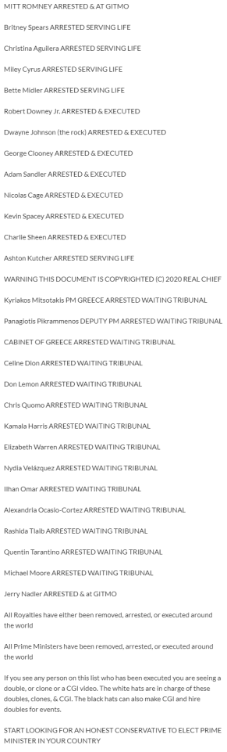
Mark Fuckerberg Rockefeller..
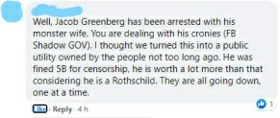
Soros, Bush, Hillary, Obama, and Biden report, Prior to them being executed.
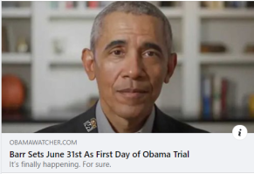
Ashton Kutcher is serving LIFE at GITMO. Symbol on Cap.
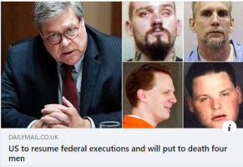
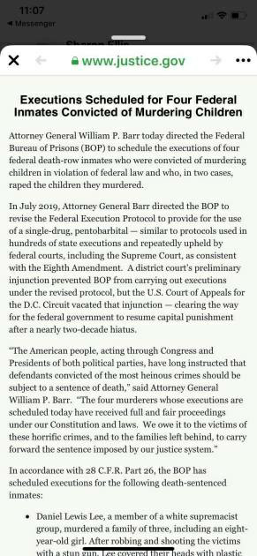
#Merkel arrested, we have talked about her arrest(s) for a while. Nobody gets away. The van in the image is the german’s prisoner transport van as described below in german. In a recent video I have said that a man will replace her. #QAnon #WWG1WGA #GITMO https://t.co/Wcq718XAwt— Utsava-ACCURATE #Trump #prophecies-#WWG1WGA (@Utsava4) June 15, 2020
May 22nd was when hanxs was taken out.
